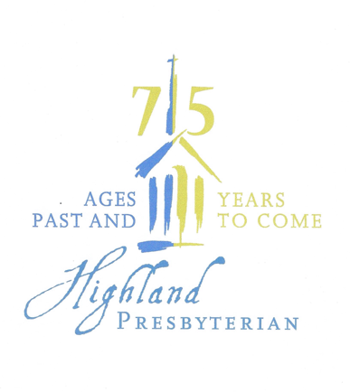 **Highland’s History – Quiz 1**

1. In what year did the steeple fall?

March 29, 1955

2. Name the restaurant where charter members met while

the church was under construction.

Town Steak House

3. What group proposed the establishment of a new church

in Ardmore?

Winston-Salem Presbytery first proposed organizing a new church in the Ardmore area. They asked the First Presbyterian Church to lead the effort.

4. How much did the church spend on the original educational building and sanctuary?

In 1956, the year the sanctuary was completed, Highland members gave $257,270.99 to pay for the building and fund the operating budget. Today that would be almost $3,000,000.

5. When was the first worship service in the newly constructed sanctuary?  Where?

The first worship service in the new building was held on Thanksgiving Day, 1950 on the first level of the sanctuary building.

 **Highland’s History – Quiz 2**

1. In what year did HPC hold its first all-church retreat at Montreat?

1981

1. Who were the two dedicated women who came to the church every Wednesday morning to prepare, cook, and serve the “Highland Fling” meals for the congregation?

Sue Grogan and Jean Loftis

3. How did the church dispose of garbage after our Fling meals?

There was an incinerator at the back of the Activity Building! A section of the current structure still shows its location.

4. Who was the first volunteer Choir Director?

Arthur Steere. He is the father of current member Susan Burroughs.

5. Name three former ministers of Highland. Which one had a child who is currently a member of the church?

Former ministers of Highland include George Staples, Gene Kirkman, Benjamin Kirkland, Steve McCutchan, Jim Banbury, Maggie Henderson, and John Watt. Rev. Gene Kirkman’s daughter, Pat Kirkman, is a member of Highland.

Suggest a Trivia Question

Do you know an interesting fact or tidbit from Highland’s past or current history?

Please share it as we continue to build upon our past and grow into the future.